2.4.1 Control Strategies
The word ‘search’ refers to the search for a solution in a problem space.
• Search proceeds with different types of ‘search control strategies’.
• A strategy is defined by picking the order in which the nodes expand.
The Search strategies are evaluated along the following dimensions: Completeness, Time
complexity, Space complexity, Optimality (the search- related terms are first explained, and then the search algorithms and control strategies are illustrated next).

Search-related terms
• Algorithm’s performance and complexity
Ideally we want a common measure so that we can compare approaches in order to select the most appropriate algorithm for a given situation.
✓ Performance of an algorithm depends on internal and external factors.

Internal factors/ External factors
▪ Time required to run
▪ Size of input to the algorithm
▪ Space (memory) required to run ▪ Speed of the computer
▪ Quality of the compiler
✓ Complexity is a measure of the performance of an algorithm. Complexity
measures the internal factors, usually in time than space.
• Computational complexity\
It is the measure of resources in terms of Time and Space.
✓ If A is an algorithm that solves a decision problem f, then run-time of A is the number of
steps taken on the input of length n.
✓ Time Complexity T(n) of a decision problem f is the run-time of the ‘best’ algorithm A
for f.
✓ Space Complexity S(n) of a decision problem f is the amount of memory used by the
‘best’ algorithm A for f.
• ‘Big - O’ notation
The Big-O, theoretical measure of the execution of an algorithm, usually indicates the time or the memory needed, given the problem size n, which is usually the number of items.
• Big-O notation
The Big-O notation is used to give an approximation to the run-time- efficiency of an algorithm; the letter ‘O’ is for order of magnitude of operations or space at run-time.
• The Big-O of an Algorithm A
✓ If an algorithm A requires time proportional to f(n), then algorithm A is said to be
of order f(n), and it is denoted as O(f(n)).
✓ If algorithm A requires time proportional to n2, then the order of the algorithm is
said to be O(n2).
✓ If algorithm A requires time proportional to n, then the order of the algorithm is
said to be O(n).

21

The function f(n) is called the algorithm’s growth-rate function. In other words, if an algorithm has performance complexity O(n), this means that the run-time t should be directly proportional to n, ie t • n or t = k n where k is constant of proportionality.
Similarly, for algorithms having performance complexity O(log2(n)), O(log N), O(N log N), O(2N) and so on.
Example 1:
Determine the Big-O of an algorithm:

Calculate the sum of the n elements in an integer array a[0..n-1].

Line no. Instructions No of execution steps
line 1 sum 1
line 2 for (i = 0; i < n; i++) n + 1
line 3 sum += a[i] n
line 4 print sum 1
Total 2n + 3
Thus, the polynomial (2n + 3) is dominated by the 1st term as n while the number of elements in the array becomes very large.
• In determining the Big-O, ignore constants such as 2 and 3. So the algorithm is of order n.
• So the Big-O of the algorithm is O(n).
• In other words the run-time of this algorithm increases roughly as the size of the input data n, e.g., an array of size n.
Tree structure
Tree is a way of organizing objects, related in a hierarchical fashion.
• Tree is a type of data structure in which each element is attached to one or more elements directly beneath it.
• The connections between elements are called branches.
• Tree is often called inverted trees because it is drawn with the root at the top.
• The elements that have no elements below them are called leaves.
• A binary tree is a special type: each element has only two branches below it. Properties
• Tree is a special case of a graph.
• The topmost node in a tree is called the root node.
• At root node all operations on the tree begin.
• A node has at most one parent.
• The topmost node (root node) has no parents.
• Each node has zero or more child nodes, which are below it .
• The nodes at the bottommost level of the tree are called leaf nodes.
Since leaf nodes are at the bottom most level, they do not have children.
• A node that has a child is called the child’s parent node.
• The depth of a node n is the length of the path from the root to the node.
• The root node is at depth zero.

22

• Stacks and Queues

The Stacks and Queues are data structures that maintain the order of last-in, first-out and first-in, first-out respectively. Both stacks and queues are often implemented as linked lists, but that is not the only possible implementation.
Stack - Last In First Out (LIFO) lists
• An ordered list; a sequence of items, piled one on top of the other. • The insertions and deletions are made at one end only, called Top. • If Stack S = (a[1], a[2], a[n]) then a[1] is bottom most element • Any intermediate element (a[i]) is on top of element a[i-1], 1 < i <= n. • In Stack all operation take place on Top.
The Pop operation removes item from top of the stack.
The Push operation adds an item on top of the stack.

Queue - First In First Out (FIFO) lists
• An ordered list; a sequence of items; there are restrictions about how items can be added to and removed from the list. A queue has two ends.
• All insertions (enqueue ) take place at one end, called Rear or Back
• All deletions (dequeue) take place at other end, called Front.
• If Queue has a[n] as rear element then a[i+1] is behind a[i] , 1 < i <= n.
• All operation takes place at one end of queue or the other.

The Dequeue operation removes the item at Front of the queue.
The Enqueue operation adds an item to the Rear of the queue.
Search
Search is the systematic examination of states to find path from the start / root state to the goal
state.
• Search usually results from a lack of knowledge.
• Search explores knowledge alternatives to arrive at the best answer.
• Search algorithm output is a solution, that is, a path from the initial state to a state that satisfies the goal test.

For general-purpose problem-solving - ‘Search’ is an approach.
• Search deals with finding nodes having certain properties in a graph that represents search
space.
• Search methods explore the search space ‘intelligently’, evaluating possibilities without investigating every single possibility.
Examples:
• For a Robot this might consist of PICKUP, PUTDOWN, MOVEFORWARD, MOVEBACK, MOVELEFT, and MOVERIGHT—until the goal is reached.
• Puzzles and Games have explicit rules: e.g., the ‘Tower of Hanoi’ puzzle

23

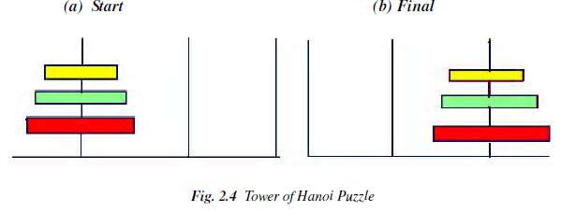

This puzzle involves a set of rings of different sizes that can be placed on three different pegs.
• The puzzle starts with the rings arranged as shown in Figure 2.4(a)
• The goal of this puzzle is to move them all as to Figure 2.4(b)
• Condition: Only the top ring on a peg can be moved, and it may only be placed on a smaller ring, or on an empty peg.
In this Tower of Hanoi puzzle:
• Situations encountered while solving the problem are described as states.
• Set of all possible configurations of rings on the pegs is called ‘problem space’.
• States
A State is a representation of elements in a given moment.
A problem is defined by its elements and their relations.
At each instant of a problem, the elements have specific descriptors and relations; the descriptors indicate how to select elements?
Among all possible states, there are two special states called:
✓ Initial state - the start point
✓ Final state - the goal state
• State Change: Successor Function
A ‘successor function’ is needed for state change. The Successor Function moves one state to another state.
Successor Function:
✓ It is a description of possible actions; a set of operators.
✓ It is a transformation function on a state representation, which converts that state into
another state.
✓ It defines a relation of accessibility among states.
✓ It represents the conditions of applicability of a state and corresponding transformation
function.

• State space
A state space is the set of all states reachable from the initial state.
✓ A state space forms a graph (or map) in which the nodes are states and the arcs between
nodes are actions.
✓ In a state space, a path is a sequence of states connected by a sequence of actions. ✓ The solution of a problem is part of the map formed by the state space.

24

• Structure of a state space
The structures of a state space are trees and graphs.
✓ A tree is a hierarchical structure in a graphical form. ✓ A graph is a non-hierarchical structure.
• A tree has only one path to a given node;
i.e., a tree has one and only one path from any point to any other point.
• A graph consists of a set of nodes (vertices) and a set of edges (arcs). Arcs establish
relationships (connections) between the nodes; i.e., a graph has several paths to a given node.
• The Operators are directed arcs between nodes.
A search process explores the state space. In the worst case, the search explores all possible paths between the initial state and the goal state.
• Problem solution
In the state space, a solution is a path from the initial state to a goal state or, sometimes, just a goal state.
✓ A solution cost function assigns a numeric cost to each path; it also gives the cost of
applying the operators to the states.
✓ A solution quality is measured by the path cost function; and an optimal solution has the
lowest path cost among all solutions.
✓ The solutions can be any or optimal or all.
✓ The importance of cost depends on the problem and the type of solution asked
• Problem description
A problem consists of the description of:
✓ The current state of the world,
✓ The actions that can transform one state of the world into another, ✓ The desired state of the world.
The following action one taken to describe the problem:
✓ State space is defined explicitly or implicitly
A state space should describe everything that is needed to solve a problem and nothing that is not needed to solve the problem.
✓ Initial state is start state
✓ Goal state is the conditions it has to fulfill.
The description by a desired state may be complete or partial.
✓ Operators are to change state
✓ Operators do actions that can transform one state into another; ✓ Operators consist of: Preconditions and Instructions;

Preconditions provide partial description of the state of the world that must be true in order to perform the action, and
Instructions tell the user how to create the next state.
• Operators should be as general as possible, so as to reduce their number. • Elements of the domain has relevance to the problem
✓ Knowledge of the starting point.
• Problem solving is finding a solution
✓ Find an ordered sequence of operators that transform the current (start) state
into a goal state.

25

• Restrictions are solution quality any, optimal, or all
✓ Finding the shortest sequence, or
✓ finding the least expensive sequence defining cost, or ✓ finding any sequence as quickly as possible.
This can also be explained with the help of algebraic function as given below.

PROBLEM CHARACTERISTICS
Heuristics cannot be generalized, as they are domain specific. Production systems provide ideal techniques for representing such heuristics in the form of IF-THEN rules. Most problems
requiring simulation of intelligence use heuristic search extensively. Some heuristics are used to define the control structure that guides the search process, as seen in the example described
above. But heuristics can also be encoded in the rules to represent the domain knowledge. Since most AI problems make use of knowledge and guided search through the knowledge, AI can be described as the study of techniques for solving exponentially hard problems in polynomial time by exploiting knowledge about problem domain.

To use the heuristic search for problem solving, we suggest analysis of the problem for the following considerations:
• Decomposability of the problem into a set of independent smaller subproblems • Possibility of undoing solution steps, if they are found to be unwise
• Predictability of the problem universe
• Possibility of obtaining an obvious solution to a problem without comparison of all other
possible solutions
• Type of the solution: whether it is a state or a path to the goal state • Role of knowledge in problem solving
• Nature of solution process: with or without interacting with the user
The general classes of engineering problems such as planning, classification, diagnosis,
monitoring and design are generally knowledge intensive and use a large amount of heuristics.
Depending on the type of problem, the knowledge representation schemes and control strategies
for search are to be adopted. Combining heuristics with the two basic search strategies have been
discussed above. There are a number of other general-purpose search techniques which are
essentially heuristics based. Their efficiency primarily depends on how they exploit the domain-
specific knowledge to abolish undesirable paths. Such search methods are called ‘weak
methods’, since the progress of the search depends heavily on the way the domain knowledge is
exploited. A few of such search techniques which form the centre of many AI systems are briefly
presented in the following sections.
Problem Decomposition

Suppose to solve the expression is: + (X³ + X² + 2X + 3sinx) dx

26

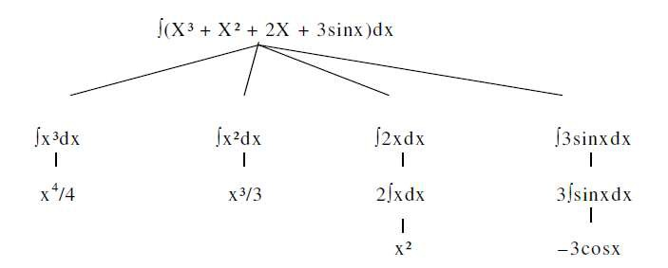

This problem can be solved by breaking it into smaller problems, each of which we can solve by using a small collection of specific rules. Using this technique of problem decomposition, we can solve very large problems very easily. This can be considered as an intelligent behaviour.

Can Solution Steps be Ignored?
Suppose we are trying to prove a mathematical theorem: first we proceed considering that proving a lemma will be useful. Later we realize that it is not at all useful. We start with another one to prove the theorem. Here we simply ignore the first method.
Consider the 8-puzzle problem to solve: we make a wrong move and realize that mistake. But here, the control strategy must keep track of all the moves, so that we can backtrack to the initial state and start with some new move.
Consider the problem of playing chess. Here, once we make a move we never recover from that
step. These problems are illustrated in the three important classes of problems mentioned below:
1. Ignorable, in which solution steps can be ignored. Eg: Theorem Proving
2. Recoverable, in which solution steps can be undone. Eg: 8-Puzzle
3. Irrecoverable, in which solution steps cannot be undone. Eg: Chess

Is the Problem Universe Predictable?

Consider the 8-Puzzle problem. Every time we make a move, we know exactly what will happen. This means that it is possible to plan an entire sequence of moves and be confident what the resulting state will be. We can backtrack to earlier moves if they prove unwise.

Suppose we want to play Bridge. We need to plan before the first play, but we cannot play with certainty. So, the outcome of this game is very uncertain. In case of 8-Puzzle, the outcome is very certain. To solve uncertain outcome problems, we follow the process of plan revision as the plan is carried out and the necessary feedback is provided. The disadvantage is that the planning in this case is often very expensive.

Is Good Solution Absolute or Relative?
Consider the problem of answering questions based on a database of simple facts such as the following:

27

1. Siva was a man.
2. Siva was a worker in a company.
3. Siva was born in 1905.
4. All men are mortal.
5. All workers in a factory died when there was an accident in 1952.
6. No mortal lives longer than 100 years.
Suppose we ask a question: ‘Is Siva alive?’
By representing these facts in a formal language, such as predicate logic, and then using formal inference methods we can derive an answer to this question easily.
There are two ways to answer the question shown below:
Method I:
1. Siva was a man.
2. Siva was born in 1905.
3. All men are mortal.
4. Now it is 2008, so Siva’s age is 103 years.
5. No mortal lives longer than 100 years.
Method II:
1. Siva is a worker in the company.
2. All workers in the company died in 1952.
Answer: So Siva is not alive. It is the answer from the above methods.
We are interested to answer the question; it does not matter which path we follow. If we follow one path successfully to the correct answer, then there is no reason to go back and check another path to lead the solution.
CHARACTERISTICS OF PRODUCTION SYSTEMS
Production systems provide us with good ways of describing the operations that can be performed in a search for a solution to a problem.
At this time, two questions may arise:
1. Can production systems be described by a set of characteristics? And how can they be
easily implemented?
2. What relationships are there between the problem types and the types of production
systems well suited for solving the problems?
To answer these questions, first consider the following definitions of classes of production
systems:
1. A monotonic production system is a production system in which the application of a
rule never prevents the later application of another rule that could also have been
applied at the time the first rule was selected.
2. A non-monotonic production system is one in which this is not true.
3. A partially communicative production system is a production system with the
property that if the application of a particular sequence of rules transforms state P into
state Q, then any combination of those rules that is allowable also transforms state P
into state Q.
4. A commutative production system is a production system that is both monotonic and
partially commutative.

28

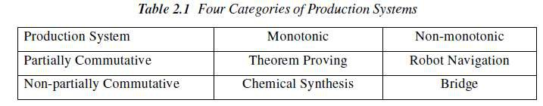

Is there any relationship between classes of production systems and classes of problems?
For any solvable problems, there exist an infinite number of production systems that show how
to find solutions. Any problem that can be solved by any production system can be solved by a
commutative one, but the commutative one is practically useless. It may use individual states to
represent entire sequences of applications of rules of a simpler, non-commutative system. In the
formal sense, there is no relationship between kinds of problems and kinds of production systems
Since all problems can be solved by all kinds of systems. But in the practical sense, there is
definitely such a relationship between the kinds of problems and the kinds of systems that lend themselves to describing those problems.
Partially commutative, monotonic productions systems are useful for solving ignorable
problems. These are important from an implementation point of view without the ability to
backtrack to previous states when it is discovered that an incorrect path has been followed. Both
types of partially commutative production systems are significant from an implementation point;
they tend to lead to many duplications of individual states during the search process. Production
systems that are not partially commutative are useful for many problems in which permanent
changes occur.
Issues in the Design of Search Programs
Each search process can be considered to be a tree traversal. The object of the search is to find a
path from the initial state to a goal state using a tree. The number of nodes generated might be
huge; and in practice many of the nodes would not be needed. The secret of a good search
routine is to generate only those nodes that are likely to be useful, rather than having a precise
tree. The rules are used to represent the tree implicitly and only to create nodes explicitly if they
are actually to be of use.
The following issues arise when searching:
• The tree can be searched forward from the initial node to the goal state or backwards from the goal state to the initial state.
• To select applicable rules, it is critical to have an efficient procedure for matching rules against
states.
• How to represent each node of the search process? This is the knowledge representation
problem or the frame problem. In games, an array suffices; in other problems, more complex data structures are needed.
Finally in terms of data structures, considering the water jug as a typical problem do we use a
graph or tree? The breadth-first structure does take note of all nodes generated but the depth-first one can be modified.
29

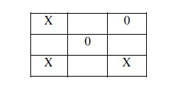
Check duplicate nodes
1. Observe all nodes that are already generated, if a new node is present.
2. If it exists add it to the graph.
3. If it already exists, then
a. Set the node that is being expanded to the point to the already existing node
corresponding to its successor rather than to the new one. The new one can be thrown
away.

b. If the best or shortest path is being determined, check to see if this path is better or worse than the old one. If worse, do nothing.

Better save the new path and work the change in length through the chain of successor nodes if
necessary.

Example: Tic-Tac-Toe
State spaces are good representations for board games such as Tic-Tac-Toe. The position of a
game can be explained by the contents of the board and the player whose turn is next. The board
can be represented as an array of 9 cells, each of which may contain an X or O or be empty.
• State:
✓ Player to move next: X or O. ✓ Board configuration:

• Operators: Change an empty cell to X or O.
• Start State: Board empty; X’s turn.
• Terminal States: Three X’s in a row; Three O’s in a row; All cells full.

Search Tree

The sequence of states formed by possible moves is called a search tree. Each level of the tree is called a ply.

Since the same state may be reachable by different sequences of moves, the state space may in
general be a graph. It may be treated as a tree for simplicity, at the cost of duplicating states.

30

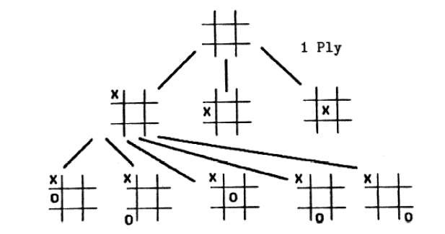

Solving problems using search
• Given an informal description of the problem, construct a formal description as a state space:
✓ Define a data structure to represent the state.
✓ Make a representation for the initial state from the given data.
✓ Write programs to represent operators that change a given state representation to a new
state representation.
✓ Write a program to detect terminal states.
• Choose an appropriate search technique:
✓ How large is the search space?
✓ How well structured is the domain?
✓ What knowledge about the domain can be used to guide the search?

31

